Lab 6 - Remote Access using SSH
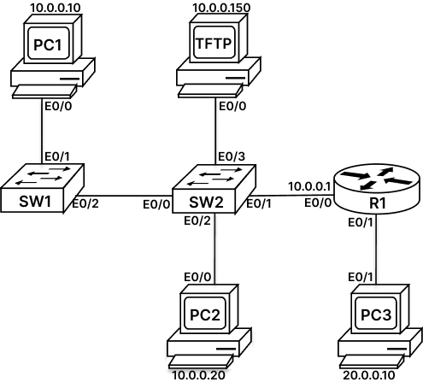

SSH (Secure Shell), sometimes referred to as Secure Socket Shell, is a protocol which allows you to connect securely to a remote device.
System and network administrators use this protocol to manage a device remotely in a highly secure manner.
SSH connection has two components: a client and a server. SSH client is an application on the computer (e.g., Putty Client) that is used to connect to the remote server. The client initiates the connection and if the credentials are verified, establishes the encrypted connection and a new session is created with the appropriate environment.
Server (in our example router) should have SSH daemon constantly listening to a specific TCP/IP port for possible client connection requests.
SSH protocol version 2 should be used for SSH server and SSH client communication (Some security issues are associated with SSHv1).
Task 1: Secure Console and Remote Access:
Let us increase the sophistication of the login process. Instead of simply using a password for remote access, lets us create a database of username and a password and provide a separate dedicated password to every administrator for remote access.
Step 1: Access the console of R1 router and enter global configuration mode. Use following command to configure username and password:
R1> enable
R1# config terminal
R1(config)# username cisco secret ?
0 Specifies an UNENCRYPTED secret will follow
4 Specifies a SHA256 ENCRYPTED secret will follow
5 Specifies a MD5 ENCRYPTED secret will follow
LINE The UNENCRYPTED (cleartext) user secret

R1(config)# username cisco secret cisco
R1(config)#
*Jan 9 05:22:21.550: End->Password:tnhtc92DXBhelxjYk8LWJrPV36S2i4ntXrpb4RFmfqY
R1(config)#
We can use option 4 and provide a SHA-256-protected secret or option 5 followed by an MD5-protected secret. These options allow us to copy the protected secret from one configuration to another.
There is also the option to specify a 0 followed by the cleartext secret. Specifying the 0 is optional and generally not used.
Step 2: Verify the configuration. Remain in the config mode and use the “do show running-config” command with filters as shown below:
R1(config)# do show running-config | include username

username cisco secret 4 tnhtc92DXBhelxjYk8LWJrPV36S2i4ntXrpb4RFmfqY
The username cisco and its password are seen in the running-config. The secret is stored as a type 4, SHA-256-protected secret in the running-config.
To use the username and password that was just defined in the user database for authenticating users connecting via VTY lines, we should change the login parameter of these lines to login local.
Step 3: Access the console of R1 router and enter the line VTY mode and configure the login local command. Also remove the previously configured password, using the no password command. We also need to configure the VTY ports to accept all type of incoming connections like telnet, SSH, rlogin, etc. as seen below:
R1# config t
R1(config)# line vty 0 4
R1(config-line)# login local
R1(config-line)# no password
R1(config-line)# transport input all
R1(config-line)# end
R1#
Task 2: Enable SSH:
The prerequisite of SSH on VTY lines is having an RSA public-private key pair. Hostname and domain name should be configured before defining key pair. Hostname is already configured on R1 router. We just need to configure a domain name and then generate a 2048-bit RSA public-private key pair.
Step 1: Access the console of R1 router and enter global configuration mode. Use following command to configure username and password:
R1> enable
R1# config terminal
R1(config)# ip ssh version 2
R1(config)#ip domain-name rst.net
R1(config)#crypto key generate rsa

The name for the keys will be: R1.rst.net
Choose the size of the key modulus in the range of 360 to 4096 for your
General Purpose Keys. Choosing a key modulus greater than 512 may take
a few minutes.

How many bits in the modulus [512]: 2048
% Generating 2048-bit RSA keys, keys will be non-exportable...
[OK] (elapsed time was 1 seconds)

R1(config)#

*Jan 10 03:02:36.641: %SSH-5-ENABLED: SSH 1.99 has been enabled
The output shows that SSH is enabled on the router.
Note: RSA is one of the most common asymmetric algorithms with variable key length, usually from 1024 to 4096 bits. The RSA algorithm has two keys, a public key, and a private key. The public key can be published and given away, but the private key must be kept secret. SSH uses the RSA algorithm to securely exchange the keys.
Step 2: From the console of SW2 Switch initiate a SSH connection to R1 Router using username cisco and password cisco. Use the following command:
SW2> enable
SW2# ssh -l cisco 10.0.0.1
Password: cisco

R1>
R1>exit

[Connection to 10.0.0.1 closed by foreign host]
SW2#
The "–l" is a hyphen with a lower-case "L" letter for "login".
Feel free to initiate the connection from PC1 and SW1.

